Ohio Association of Professional Fire Fighters
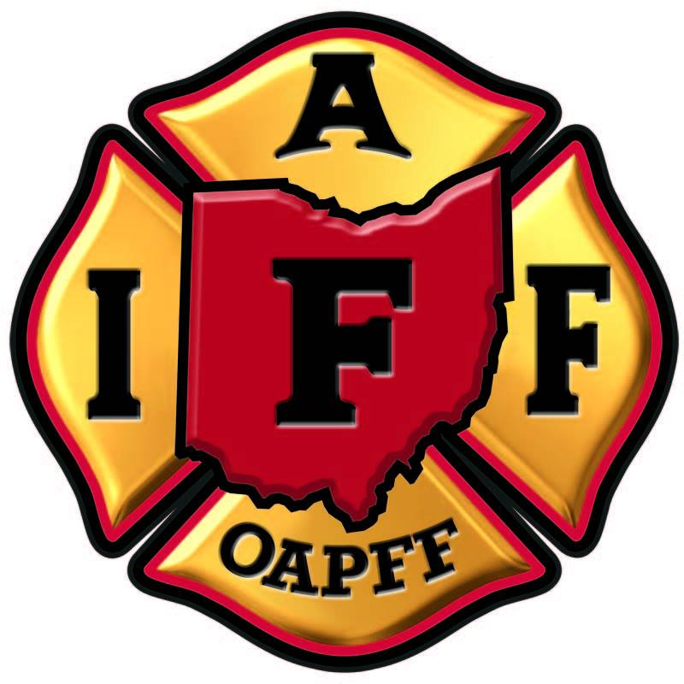
Official Minutes
______________________________________________________________________________
Meeting of the Executive Board
January 19th 2022

President Taylor called the meeting to order

Secretary-Treasurer Quinn called the roll. The following Board Members and Staff were present:
President – Michael P. Taylor

Secretary-Treasurer - William E. Quinn Jr.

1st District Vice President – Roy Hollenbacher

2nd District Vice President – Michael Norman

3rd District Vice President – Cory Wilson

4th District Vice President – Jon Harvey

5th District Vice President – Dave Montgomery

Retiree Vice President – Thomas Rave

Sergeant-at-Arms – Daniel Mitsch

Trustee – Jeff Younkins

Trustee – Ryan Launder

Trustee – Rich Goforth

Director of Governmental Affairs – James Carney (Excused)

Director of Communications – Mark Hill

Director of Health, Safety & EMS – David Bernzweig

Director of Operations – Bill Mastroianni

Metro Representative – Dan Desmond
Guests in attendance:

Matt Alter Local 48
Steve Stein Local 67
Ben Leonard Local 1729
John Jerina Local 204
Jeff Moore Local 3518
John Harbaugh Local 4038
Brian Gatley Local 1723

TRUSTEES REPORT

Trustee report given by Goforth. Trustees say we are up to date. Physical audits start at the end of the month
SECRETARY-TREASURERS REPORT

Financial report given by ST Quinn he gave expenditures and operating funds report/numbers. IRS taxes given. Payments quoted for all expenses. IRS payroll taxes. General council payment. AFL-CIO dues quoted. Battle of Ohio cost. Donated money to Springfield Township and Columbus locals. Cost of N.O.A academy given. Cost of upcoming Winter Ed quoted. CPA payments along with cell phone bill. Reserve fund policy quoted. PCE monies quoted. Balances given. Expenditure from PCE given.
Fire PAC monies quoted, and balance given. Expenditure given.

457 report/information told to everyone in attendance. Noted that not everyone is a member. Prospective 457 plan managers/advisors were interviewed of them, and report given on each. Currently in negotiations with one of the 3 companies interviewed. ST Quinn submitted 2022 budget to Eboard in working session prior to Eboard meeting. he is preparing to send fiscal info to all locals including budget.

Mr. Quinn says IRS changed mileage rules/amounts

PRESIDENTS REPORT

Pres. Taylor says Director Mastroianni will talk about upcoming conference soon. Mike spoke about the joint OAPFF/FOP press conference on pension reform. Rep. Baldridge and Rep. Abrams are cosponsors of HB 512. Mr. Taylor talked with State Supreme Court Judge Brewer about an endorsement. He made a Motion: “To endorse Judge Brewer” and asked for discussion. Motion was seconded. Passed Unanimously.

Pres Taylor spoke on the upcoming Biennial conference. He says the Toledo hotel gave away our dates and now we moved the conference to Cleveland and Local 93 is going to host. Constitution and By-Laws says there must be a vote to move it. Motion “To move biennial conference to Cleveland”. There was discussion and VP Montgomery voted no. All other VPs voted Yes

The president talked briefly about Peer support legislation.

COMMITTEE REPORTS: Nothing Reported

Ohio Association of Professional Fire Fighters
Official Minutes
______________________________________________________________________________

STAFF REPORTS

Operations:

Mr. Mastroianni says the 53rd Biennial Convention will be held in Cleveland Monday May 16th to Thursday May 19th. He says Joan is working on credentials. Bill mentioned how the Winter Ed was canceled last year and monies from then were applied to this year’s conference on Feb 14th-16th. He says there was a slight cost increase due to a longer period this year. Bill says Dir. Bernzweig is helping with agenda and speakers. Dir. Mastroianni says last October N.O.A attendance was a success and he also mentioned that the Battle of Ohio was another success. Bill is working with Dir. Bernzweig on several projects. The Director said that the 3rd saturday in September in Colorado will be the Fallen Fire Fighter memorial. Director Bill says several hundred members have gone through the Higher Education Initiative. Mr. Mastroianni says a BS degree can now be attained. He says retirees are eligible to participate if they’re active in the retiree organization. PSOB has not been denied for COVID deaths according to Bill and FEMA will cover up to $9000 for funeral costs.

Health, Safety, and EMS

Director Bernzweig is working with Dir. Carney on peer support legislation. He expects introduction of agreeable legal language soon. Dave says the OAPFF peer support team has been a role model for IAFF. The Director talked about the Kentucky tornado tragedy and the help provided to them. He says local 93 is hosting a peer support class. Dave says he is working with Dir. Mastro on Winter Ed agenda. He says there will be a report on Surfside bldg. collapse. Dave is on the NFPA committee that is rewriting some NFPA 1582 language. He says there has been some work on revising turnout gear language in NFPA.

Ohio Association of Professional Fire Fighters
Official Minutes
______________________________________________________________________________

Governmental Affairs

Director Carney’s report given by Pres. Taylor. He says Jim is awaiting neck surgery. Mr. Carney has been working remotely. Jim had over 40 legislative interactions so far this year. He says some things are on hold until gerrymandering issue is resolved. The Director met with Tim Berga from AFL-CIO and has been working on pension reform with all concerned parties. He is working with legislators on several fire fighter related bills. Most bills are moving, a few are not.

Communications and PR

Over the last couple of months, Mark has been working on keeping 2 websites up to date. If anyone has any information that they see needs to be added or corrected on oapff.org or oapff457plan.com, please contact him.

Director Hill is currently making sure that registrations for the upcoming Winter Ed health and safety conference go through to Bill Mastroianni. If any members are having problems, please call Mark so there are no delays in getting signed up.

Mr. Hill sent out an end of year newsletter that went out a few days before Christmas, if you or your members did not receive it contact him about getting on the OAPFF mailing list.

With that note on mailing list, oapff.org has now surpassed 12,000 registrations. He know’s that not everyone registered with oapff.org is on our general mailing list, but if you want to stay up to date on all communications make sure your website login is correct.

Mark has put a link on oapff.org for IAFF SMART if our locals need to access it

As always if your locals have information, they would like to post on our social media have them contact me. As a word of caution If they are partnering with a 3rd party organization that is asking for money/donations or soliciting something I will be hesitant to post it. Obviously if it’s for the local (fish fry, toy drive, hardship drive for a member) I will happily post that.

Ohio Association of Professional Fire Fighters
Official Minutes

Legal

Mr. Henry Arnett has been sending out letters to Eboard and staff on legal fights going on across the state. He mentions that a ULP was filed with SERB on cameras in firehouses (Sharonville). He says SERB agreed with fire unions saying they must be bargained for. He talked about a PTSD study done by the pension fund and who should handle potential future claims. He talked about (COLERA?) Zoom classes. He highly recommends fire fighters attend these classes.

Metro Representative – Dan Desmond.

Mr. Desmond talked with Local 67 and Local 48 about endorsement on Mayor Cranley. He talked to Local 93 about contract issues. He talked about a legal case going on with Local 92 and a recruit that was fired.

Retiree VP – Tom Rave.

Mr. Rave: spoke about pension issues and Ohio Retirement Council and says OP and F is down to 25-year funding. Tom says health care stabilization fund is at 17 yr. funding level. He got a call from a member who says members are receiving bad info from other people about receiving stipend. VP Rave says he and Carl Jordan are working on about 20 disability cases. Tom Rave mention how members are getting what they need from BWC. He says things are moving well right now. Tom says no one knows long term effects of COVID and how that will affect BWC/disability issues.

1st District – DVP Hollenbacher

DVP Hollenbacher talked about the former trustees who recently passed, they were both district one members, Lenny Martin, and Dan Ross. He attended ALTS and talked about a township trustee race in Ontario OH that received help from the IAFF. He says a FF whose dad passed has issues getting his name on the wall in Colorado and they got help from IAFF personnel. Roy is helping Bucyrus with negotiations.

Ohio Association of Professional Fire Fighters
Official Minutes
______________________________________________________________________________

2nd District – DVP Norman

DVP Norman is assisting in negotiations with Local 93. He says there is a new mayor in Cleveland and Pres. Lally was re-elected as Pres of Local 93. He mentioned bill of rights in their contract. He thanked DVP Harvey for his help. He congratulated the Bengal’s

3rd District – DVP Wilson

DVP Wilson is helping several locals with negotiations. Cory talked about a new local in Bryan OH. Mr. Wilson mentioned contract talks in Chester township, Perry Township, and Massillon.

4th District - DVP Harvey

DVP Harvey says if youre in contract talks please submit with SERB. He had a meeting with SERB employee about wage increases. Jon talked about organizing and working with DVP Norman on forming a new local in district 2. He thanked the Arnett’s for being quick to respond. There were issues in Pierce Township. Mr. Harvey says SAFER is now open so please apply and ask for help with applying. He thanked DVP Sanders for getting help from the IAFF with emergency funds. He says 457 changes will be good for our members.

5th District – DVP Montgomery

Montgomery: Motion “That the OAPFF ST make available to executive board all revenue and expenditures of the OAPFF as part of his or her financial report.” DVP Hollenbacher discussed. Metro DVP Desmond discussed. Motion passed unanimously. Dave is in negotiations with several locals as well as assisting several locals on getting legal counsel. He says employers are just settling with locals so as not to lose them.

Guest Speakers

Pres. Lally of Local 93 welcomes all members to the upcoming OAPFF 53rd Biennial conference. He thanked OAPFF with contributions in mayoral race. He says peer support training is needed and Local 93 is very thankful for it.

Pres. Alter of Local 48 says there is no mandatory OT for Local 48. He says brownouts have been implemented in Local 48 and it has caused a rift between members. They have a class starting
Ohio Association of Professional Fire Fighters
Official Minutes
______________________________________________________________________________

(cont’d) in Oct. Pres. Alter says a new COVID policy has been implemented there, they are fighting it and SERB ruled against them. Cincinnati has a new mayor and council there.

Pres. Stein spoke about several line of duty deaths in Local 67 due to COVID. If someone is having COVID issues, please reach out to Local 67. He thanked the Arnett’s with their help.

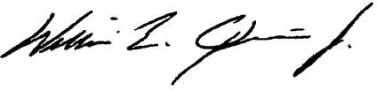
The meeting was adjourned.

William E. Quinn Jr.
Secretary-Treasurer

